HEMATOLOGY ANALYZER.
Introduction
Hematology comes from two Greek words i.e. Haimas meaning blood and Logos meaning science.
Hematology is thus the science or study of blood.
Hematology is further defined as the branch of biology concerned with the study of blood, blood forming tissues and blood diseases.
Hematological Test
Hematological tests can evaluate numerous conditions involving blood and its components.
They can also be used to diagnose inflammation, anemia, infection, hemophilia, blood clotting, and leukemia etc.
Hematology Analyzer Machine
Definition
These are computerized, highly specialized and automated equipment that count the different kinds of blood cells; RBCs, WBCs & Platelets as well as computing their respective indices, presenting results as actual cell counts, percentage cell distributions, hemoglobin concentration, histograms & scatter grams.
Hematology analyzers are used widely in patient and research settings to count and characterize blood cells for disease detection and monitoring.
The machine analyses blood parameters i.e.
- Blood Cells count e.g. WBC count, RBC count, Platelets count, hemoglobin levels and hematocrit levels
- Analyzes RBC indices like Red Cell distribution width (RDW), Mean Corpuscular volume (MCV), Mean corpuscular Hb (MCH)), Mean corpuscular Hb Concentration (MCHC), WBC differential count in percentage, and absolute values.
- Analyzes platelets indices like platelets distribution width, mean platelets volume, platelets large cell ratio and platelets crit.
N/B The original hematology analyzers first appeared in the 1950s, but the truly functional and automated versions of these machines did not become available for two more decades. Before this time, cell counts were performed manually.

Types of Automated Analyzers
These analyzers are of two types based on the type of differential White Cell Count i.e. 3-part differential cell counter and 5 - part differential cell counter.
3 - Part Differential Cell Counter | 5 - Part Differential Cell Counter
It operates on the principle of electrical impedance to determine to determine the size and volume of the cells. | Uses flow cytometry and volume conductivity scatter to determine granularity, diameter and inner complexity of blood cells
It differentiates WBCs into neutrophils, lymphocytes and mixed cell counts. Its unable to distinguish between monocytes, eosinophils and basophils. | It differentiates WBCs into neutrophils, lymphocytes, eosinophils, monocytes and basophils.

Working/ Operation Principle of Hematology Analyzer
Automated analyzer aspirates the required quantity of blood sample, quantifies, classifies and describes cell populations using both electrical and optical techniques.
The three main technologies used in the automated hematology analyzers are;
- Photometric method/Colorometry
Most analyzers use this method to determine Hemoglobin concentration, similar to the cyanmethHb.
In this technique, Whole blood added to an isotonic-conductive diluent is delivered to the RBC Chamber then mixed with a precise volume of lyse, converting this to a Hb complex whose Absorbance is measured by a monochromatic light at 525nm.
In the absorbance measurement, a monochromatic light from the light source is passed through the lysed solution in the RBC chamber; the absorbance of the solution is measured by a photo sensor in the Hb flow cell calculating the Hb concentration.
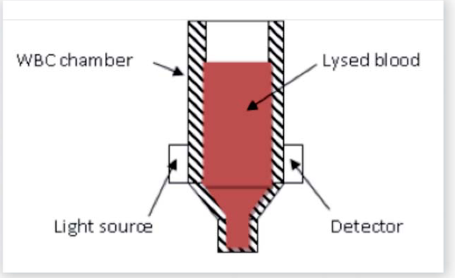
Absorbance = log10 (V_{R}/V_{S})
V_{R}= Reference Voltage
V_{S}= Sample Voltage
- Electrical Impedance
This is the traditional method for counting WBCs, RBCs and Platelets. It’s also known as the Coulter Principle and is used in almost every hematology analyzer.
Whole blood is passed between two electrodes through an aperture so narrow that only one cell can pass through at a time.
As each cell passes through the aperture, a change in electrical impedance (resistance) occurs generating a voltage pulse.
The number of generated pulses correlates with the number of cells, whereas the size of the pulse is related to the cell size.
The amplitude of each pulse is directly proportional to the cell volume.
The different cell components are depicted in respective histograms as per their size distribution.
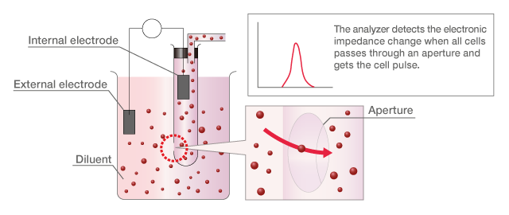

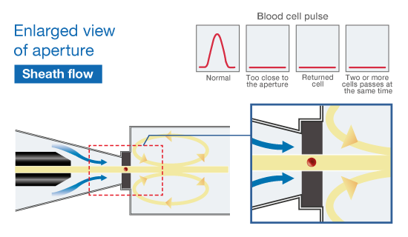

- Laser-Based Flow-Cytometry (for 5-part)
In this method, optical measurement of light scattering and diffraction is used to determine the 5-part WBC (LYM, MON, NEU, EOS, BAS) differential parameters.
An optical measuring head with focused laser source is used to illuminate a stream of WBCs suspended in an optically clear diluent moving through a flow cell. The cells scatter light as they flow through the path of the laser beam.
The absorbance is measured, and the scattered light is measured at multiple angles to determine the cell’s granularity, diameter, and inner complexity.
An optical detector senses changes in the intensity of the scattered laser light which are proportional to the cell volume and intracellular structure.
Based on the size, granularity and nuclear structure, the 5 types of WBCs are separated in three dimensional spaces and depicted as scatter grams.
N/B - Scatter gram is a three dimensional pictorial display of the distribution of WBCs based on their size and granularity causing light scatter.
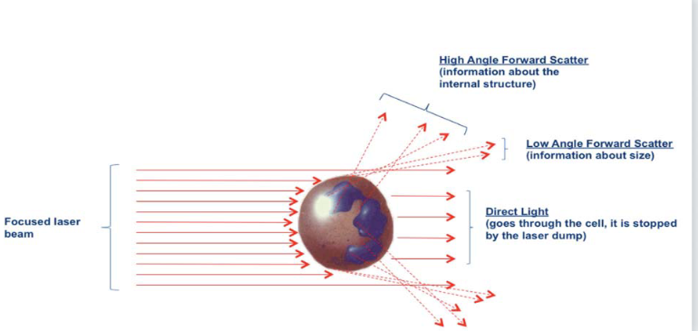

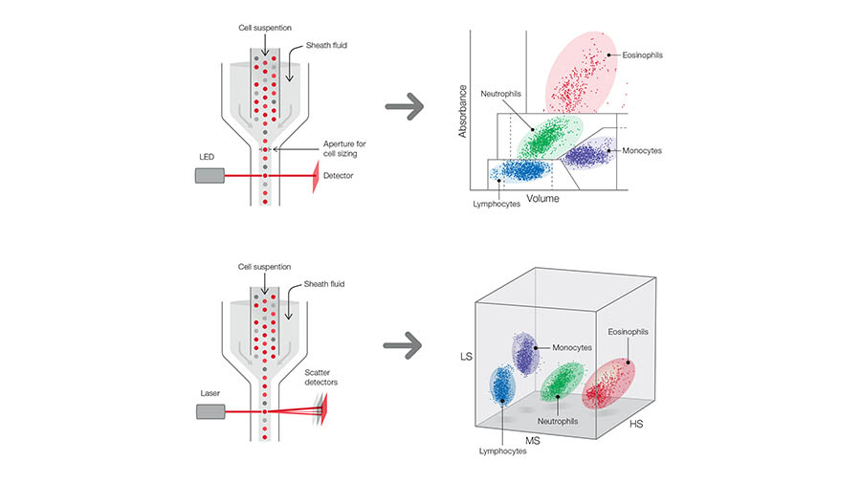

N/ B -Laser flow cytometry is more expensive than impedance analysis, due to the requirement for expensive reagents, but returns detailed information about the morphology of blood cells. It is an excellent method for determining five-part WBC differentials.
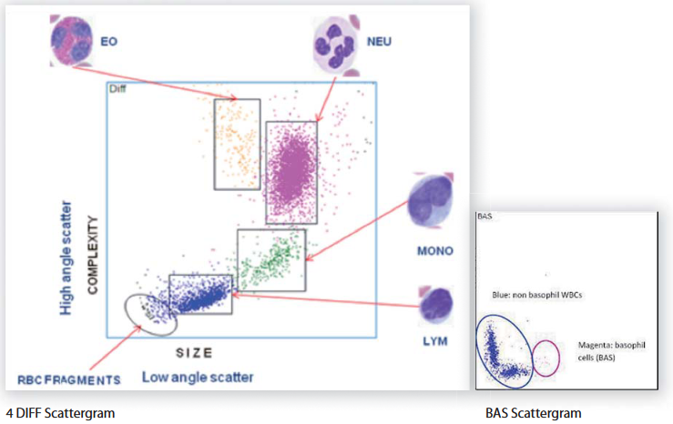
3-D Scatter gram
MEASURED PARAMETERS in 3/5-PART ANALYZERS
- Number of RBC
- Hemoglobin level
- Number of WBC
- Number of Granulocytes
- Number of Lymphocytes
- Number of Monocytes
- Number of Platelets
- Number of Neutrophils
- Number of Basophils
- Number of Eosinophils
CALCULATED PARAMETERS, 3/5-PART ANALYZERS
i) RBC indices: MCV, MCH, MCHC, RDW-cv,
RDW-sd, HCT.
ii) WBC indices: %G, %L, %M, %N, %E, %B, %ALY,
%LIC.
iii) PLTs indices: MPV, PDW, PCT, P-LCR, P-LCC
HISTOGRAMS And 3D-SCATTERGRAMS
- WBC Histogram
- RBC Histogram
- PLT Histograms
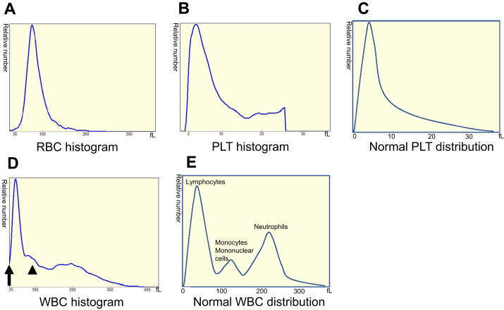
- DIFF Scatter gram
- Basophil Scatter gram
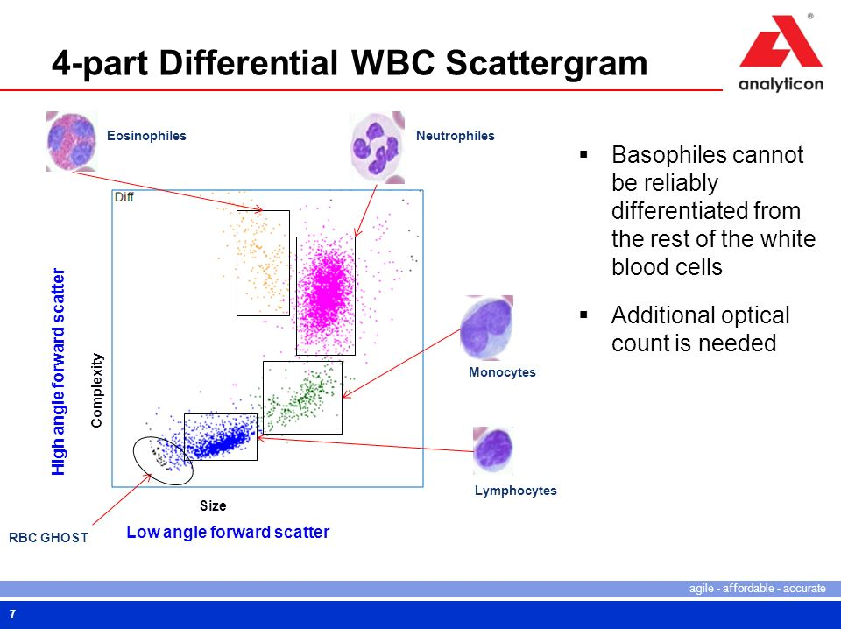
KEY COMPONENTS OF HEMATOLOGY ANALYZERS
i) Hydraulic System
- Aspirating & Dispensing probe
- Diluters & Chambers
- Aperture/Orifice
- Photometer
ii) Pneumatic System
- Vacuum Pumps
- Directional Valves
iii) Electronic System
- Power supply board
- Control & computing circuit boards
TECHNICAL PROBLEMS ASSOCIATED WITH HEMATOLOGY ANALYZERS
- Obstruction of aperture
- Clogging of sample needle
- Worm-out or leaking pump tubes
- Malfunction of the directional valve
- Blockage of the solenoid valve
- Insufficient sample intake
- Pressure error
- Pneumatic system error
- Electronic sensor failures
- Malfunction of power/computing circuit boards
- Malfunction of the analyzer software
- Unstable current or earth leakage
USER & TECHNICAL SERVICE MAINTENANCE
- Calibration (Manual & Auto), touchscreen
- Cleaning: Daily, Weekly, unclogging
- Comprehensive: Fluidics initialization, Auto clean,
Cleaner-soak, Chamber flushing
- Diagnostic Self-Test
- Troubleshooting, identifying problems, malfunctions and
dealing with errors
- Software upgrade & LIS integration

BY MR OKUKU

